Lesson 2 plan: Functions using SUM, AVERAGE, MAX and MIN
About the lesson
This lesson introduces students to using some of the standard functions: SUM, AVERAGE, MAX and MIN. They will learn how to write each of the formulae and apply it to a data set using cell ranges. They will then apply this learning to practical activities using the spreadsheets provided.
Learning objectives
By the end of this lesson, students will
- be able to write functions to calculate totals and averages using cell ranges.
- be able to write functions to find the largest or smallest value in a range.
- choose the appropriate function to complete a task.
National Curriculum
The following subject content from the KS3 National Curriculum is included in this lesson:
- Design, use and evaluate computational abstractions that model the state and behaviour of real-world problems and physical systems.
- Understand the hardware and software components that make up computer systems.
Links
The ability to write and use functions correctly in spreadsheets is needed to support the use of spreadsheets in any other subject. There are more direct links with subjects such as maths and the sciences where the same functions are likely to be used.
Key terminology
function, function name, cell range, parentheses, SUM, AVERAGE, MAX and MIN
Teaching and learning activities
Share the objectives for the lesson with students (Slide 2 of Lesson 2 presentation).
Starter
Show students an example of a spreadsheet (Slide 3).
Ask: What formula would you write in cell H3 to add the numbers together?
From the last lesson’s work, students should be able to identify the formula: =A3+B3+C3+D3+E3+F3+G3.
Explain that this will generate the correct answer, but it is quite a long formula and it is easy to make an error when typing it.
Part 1
Explain the benefit of using functions for longer or more complex calculations (Slide 4 and page 20 of the Student Book).
Explain the structure of a function (Slide 5 and page 20).
Check understanding of new terminology.
Show students Slide 6 and ask them to identify the function name, the cell range and the parentheses.
Part 2
Demonstrate how to write a SUM function (Slide 7 and page 20, plus Video 2.1).
Ask students to complete Activity 2.1: Using SUM (Slide 8, Excel workbook 2, sheet 1/Excel workbook 2.1; Google Sheets workbook 2, sheet 1/Google Sheets workbook 2.1.)
Common misconceptions
Students often confuse the SUM function with a basic formula such as =A1+B1+C1, and amalgamate the two ideas into something like =SUM(A1+B1+C1). A direct question such as, ‘Do we need to use a plus sign inside the brackets when using SUM?’ may help to alert students to their error.
Some students may try to use =ADD rather than =SUM. Use questioning to make sure that they understand the correct keyword to use for the function.
Answer
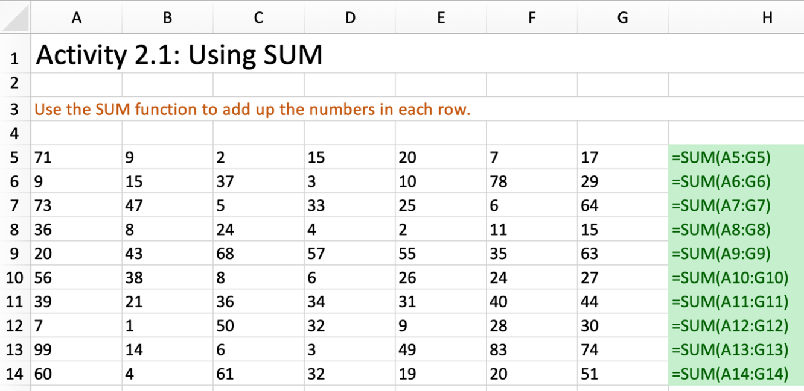
- Make sure students are using =SUM and not writing a formula referencing every individual cell.
- Check that they are using the correct cell range for each row.
Part 3
Demonstrate how to write an AVERAGE function (Slide 9 and page 20, plus Video 2.2).
Ask students to complete Activity 2.2: Using AVERAGE (Slide 10, Excel workbook 2, sheet 2/Excel workbook 2.2; Google Sheets workbook 2, sheet 2/Google Sheets workbook 2.2).
Common misconceptions
Some students may try to use =MEAN rather than =AVERAGE. Use questioning to make sure that they understand the correct keyword to use for the function.
Answer
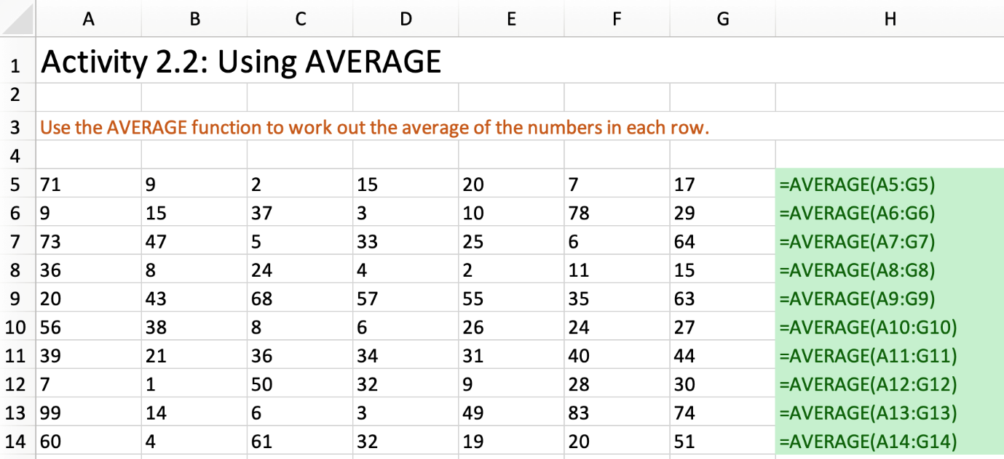
- Make sure that they are using =AVERAGE.
- Check that they are using the correct cell range for each row.
Part 4
Demonstrate how to write MAX and MIN functions (Slide 11 and page 20, plus Video 2.3).
Ask students to complete Activity 2.3: Using MAX and MIN (Slide 12, Excel workbook 2, sheet 3 /Excel workbook 2.3; Google Sheets workbook 2, sheet 3/Google Sheets workbook 2.3).

Answer
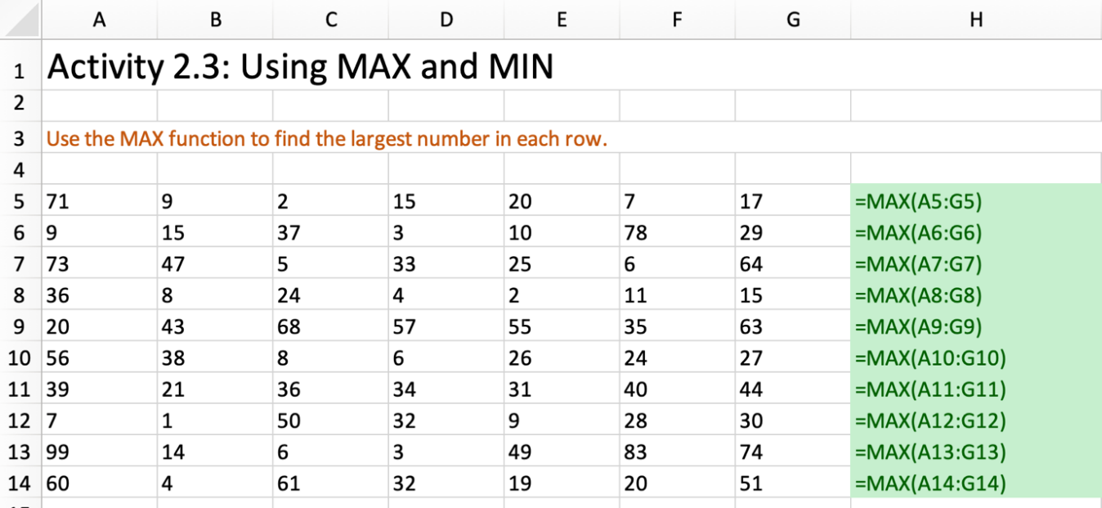
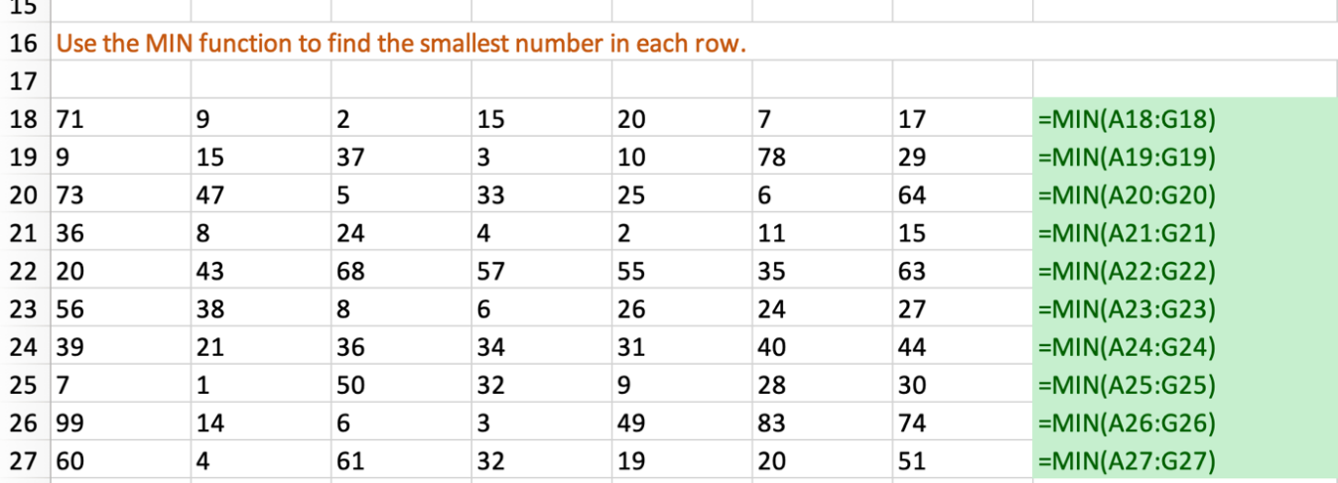
- Make sure that they are using =MAX and =MIN.
- Check that they are using the correct cell range for each row.
Part 5
Encourage students to consolidate their learning by asking them to complete:
- Activity 2.4: Basic functions (Slide 13, Excel workbook 2, sheet 4/Excel workbook 2.4; Google Sheets workbook 2, sheet 4/Google Sheets workbook 2.4)
- Activity 2.5: Cinema tickets (Slide 14, Excel workbook 2, sheet 5/Excel workbook 2.5; Google Sheets workbook 2, sheet 5/Google Sheets workbook 2.5)
- Activity 2.6: Pocket money (Slide 15, Excel workbook 2, sheet 6/Excel workbook 2.6; Google Sheets workbook 2, sheet 6/Google Sheets workbook 2.6)
- Activity 2.7: Birthday cake (Slide 16, Excel workbook 2, sheet 7/Excel workbook 2.7; Google Sheets workbook 2, sheet 7/Google Sheets workbook 2.7).

Answers
Activity 2.4
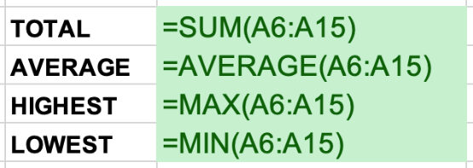
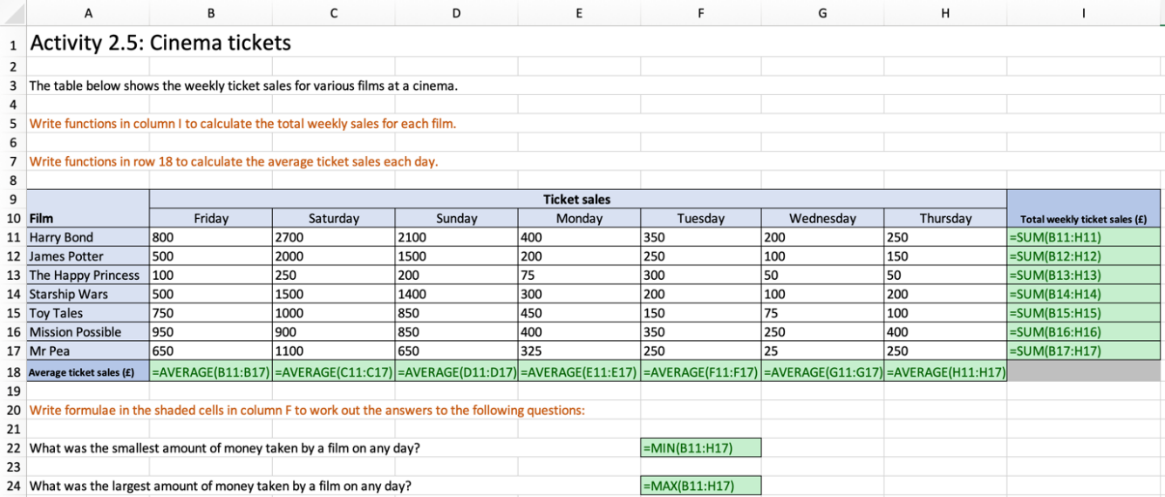
Activity 2.5
Activity 2.6
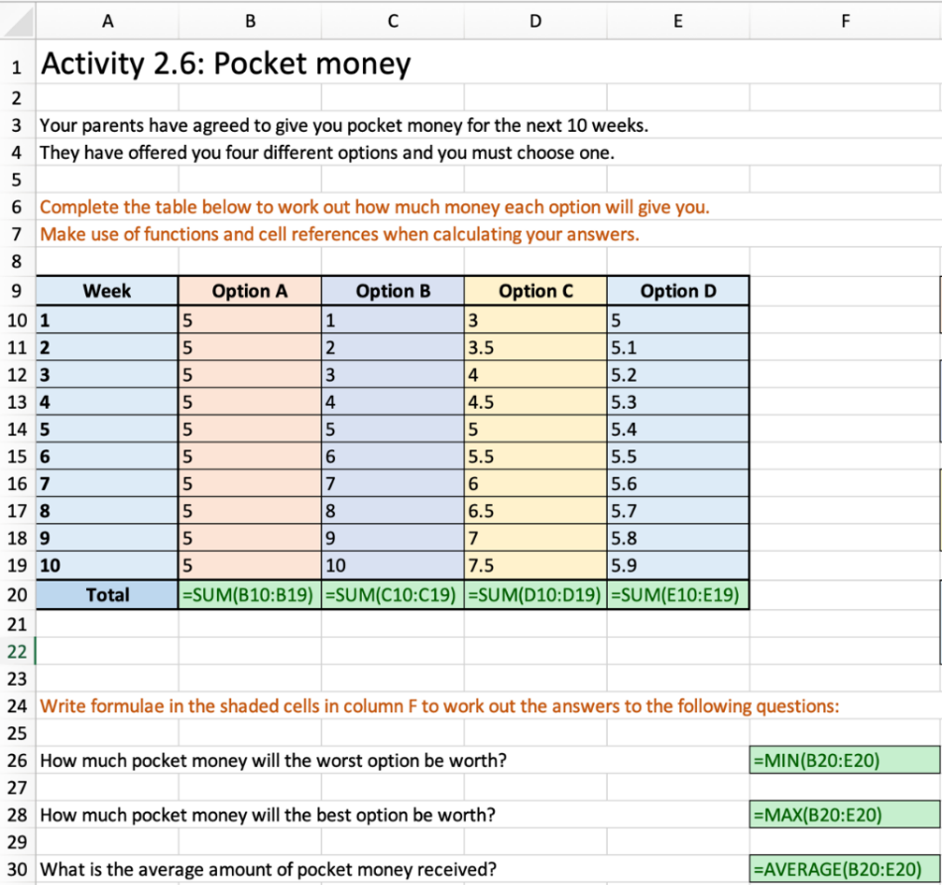
Activity 2.7
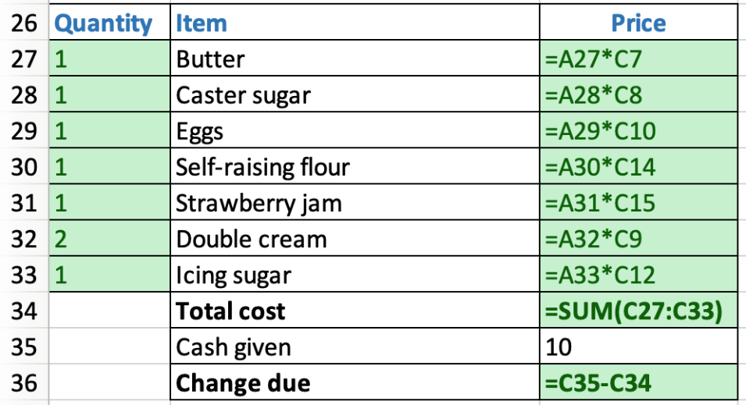
Plenary
Check students’ knowledge and understanding with a short question and answer session linked to the learning objectives for the lesson.
- Give an example of a cell range.
(Example answer: C1:C5)
- Why would you use the SUM function rather than writing a formula?
(Example answer: It is much quicker and easier to use a function, and you are more likely to make a mistake when writing a formula.)
- Which function would you use to find the largest value in a set of data?
(Answer: MAX)
Homework
Ask students to complete any activities they did not finished during the lesson.
Ask students to complete Quiz 2.
Stretch activities
Students who complete the activities in this lesson quickly could be encouraged to find out about a wider range of pre-set functions available in spreadsheet applications, and to consider where they might be used to help complete work in other subjects.
Support activities
Some students may benefit from focussing on one type of function at a time so that they can build confidence in using it correctly before proceeding to a different function.
Some students may need guiding towards the correct function to use when completing the activities on the final spreadsheet.
Encourage students to click on the required cell, or cells, when entering formulae to avoid simple typing errors.
A number of short and informative videos can be found online that demonstrate the use of features in spreadsheets such as: www.youtube.com/c/microsoft365/playlists?view=50&sort=dd&shelf_id=5 for MS Excel and www.youtube.com/channel/UCco3PQfioWg5uFBxi1ndb2A for Google Sheets.

